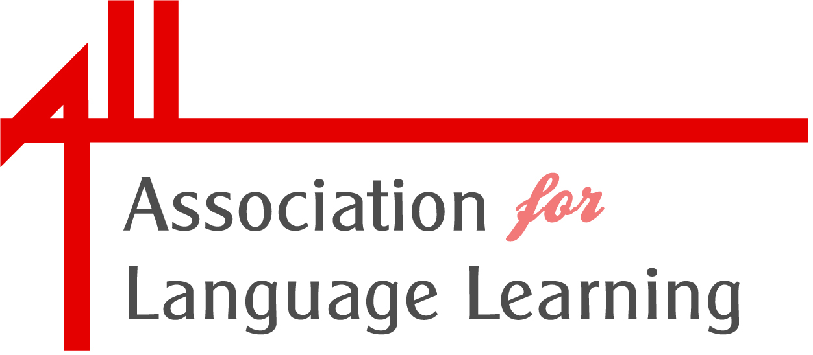

Nomination Form for ALL Fellowship 2016

ALL fellowship is honorary and is awarded at the discretion of the Management Board (the Association’s Board of Trustees). Suggestions are considered annually at the Spring meeting of the Board, in advance of Language World Conference, but awards are not necessarily made each year. Nominations are now invited.
The fellowship recognises ALL Individual Members who have made a long-standing contribution to language learning in the UK, beyond the call of their professional role and who have supported the work of the Association significantly over time; their contribution might be on the national or local scale.

Before nominating somebody, please check that the person concerned wishes to be nominated and would accept the award if successful.

This nomination is made by:

Your Name …………………………………………………………………………………………………………………..

Your membership no. ……………………………………………………………………………………………………..

Your email address

The person I wish to nominate is : ……………………………………………………………………………………..

Capacity in which the fellowship nominee is known to you:

………………………………………………………………………………………………………………………………………….

………………………………………………………………………………………………………....................................

Reasons for nomination (a maximum of 250 words, relating to fellowship criteria):

………………………………………………………………………………………………………………………………………….

…………………………………………………………………………………………………………………………………………...

……………………………………………………………………………………………………………………………………………………..

.…………………………………………………………………………………………………………………………………………………….

……………………………………………………………………………………………………………………………………………………..

……………………………………………………………………………………………………………………………………………………..

……………………………………………………………………………………………………………………………………………………..

……………………………………………………………………………………………………………………………………………………..

…………………………………………………………………………………………………………………………………………………….

I confirm that I have approached the nominee about their willingness to accept the award.

Your Signature:

Date:

Please send this completed nomination form (dated and signed) by the close of Monday 15 February 2016 to victoriac@all-languages.org.uk or via the post to:

Victoria Copley
Administrative Officer
Association for Language Learning
University of Leicester
University Road
Leicester
LE1 7RH

